Employee Salary Prediction Project - Detailed Workflow
Project Overview
This project predicts employee salaries using a machine learning model and provides an interactive Streamlit application.

Workflow
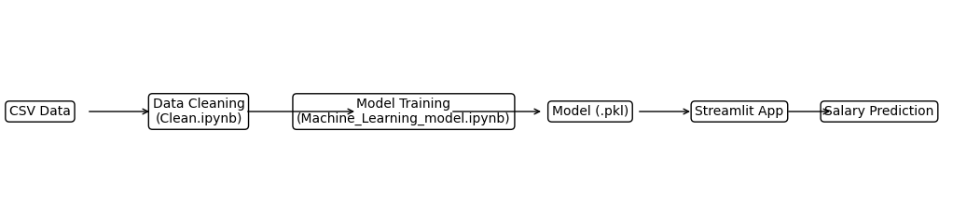

1. Data Collection
Input dataset: employee_salaries_large.csv containing employee department, designation, experience, college tier and salary.

2. Data Cleaning
Performed in Clean.ipynb. Typical tasks include handling missing values, removing duplicates, encoding categorical columns and preparing the dataset.

3. Model Training
Machine_Learning_model.ipynb trains the salary prediction model and exports Salary_Prediction.pkl.

4. Streamlit Application
Demo_App.py loads the trained model, accepts user inputs and predicts salary.

5. Prediction Process
User selects Department, Designation, Experience and College Tier. The application creates a DataFrame, passes it to the trained model and displays the estimated salary.

Project Structure
- employee_salaries_large.csv – Raw dataset
- Clean.ipynb – Data preprocessing
- Cleaned_Employees_salaries_Data.csv – Cleaned dataset
- Machine_Learning_model.ipynb – Model training
- Salary_Prediction.pkl – Trained model
- Demo_App.py – Streamlit user interface

Future Improvements
Add model evaluation metrics, feature importance, visual dashboards, model versioning, deployment to cloud and API integration.

